**CYBER SECURITY – CA2**

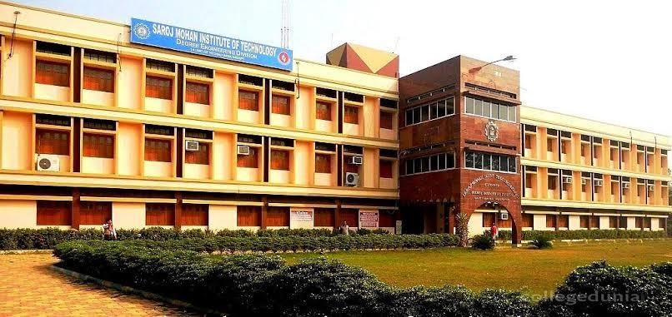

Name -> Ashi Senchoudhury

Roll no -> 16800119014

College -> Saroj Mohan Institute of Technology

Department -> CSE

Year-> 4th

Paper -> Cyber Security (PEC CS702E)

Topic-> Virtual Machine Technology and its types

# INDEX-

|  |  |  |
| --- | --- | --- |
|  | **TOPIC** | PAGE NO |
| 1) | What is a virtual machine? | **3** |
| 2) | How do VMs work and Two types of hypervisors. | **4** |
| 3) | Advantages and Downsides of VMs | **5** |
| 4) | VMs and containers | **6** |
| 5) | Conclusion | **7** |

**What is a Virtual Machine?**

A virtual machine (VM) is software that runs programs or applications without being tied to a physical machine. In a VM instance, one or more guest machines can run on a host computer.

Each VM has its own operating system, and functions separately from other VMs, even if they are located on the same physical host. VMs generally run on servers, but they can also be run on desktop systems, or even embedded platforms. Multiple VMs can share resources from a physical host, including CPU cycles, network bandwidth and memory.

VMs trace their [origins to the early days](https://www.networkworld.com/article/3234795/what-is-virtualization-definition-virtual-machine-hypervisor.html) of computing in the 1960s when time sharing for mainframe users was used to separate software from a physical host system. A virtual machine was defined in the early 1970s as “an efficient, isolated duplicate of a real computer machine.”

VMs as we know them today have gained steam over the past 20 years as companies adopted [server virtualization](https://www.networkworld.com/article/3285906/whats-the-future-of-server-virtualization.html) in order to utilize the compute power of their physical servers more efficiently, reducing the number of physical servers and saving space in the data center. Because apps with different OS requirements could run on a single physical host, different server hardware was not required for each one.

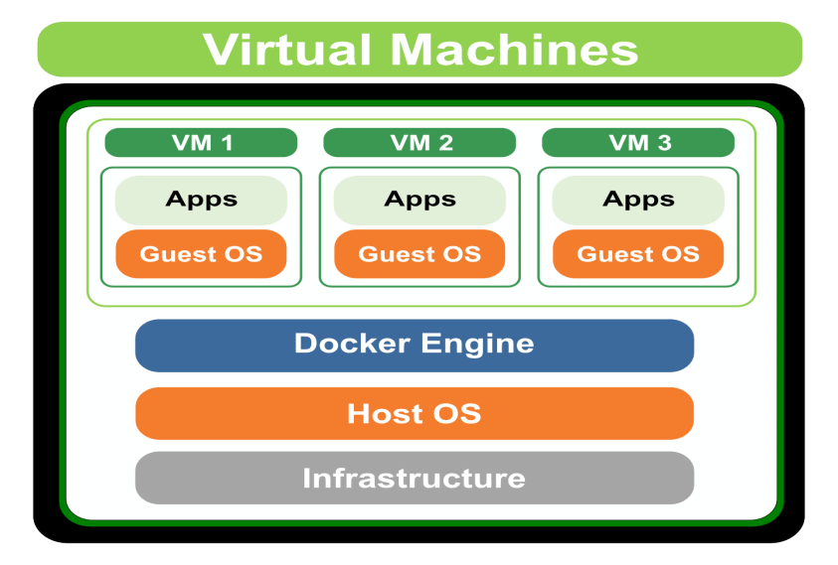

**How do VMs work?**

In general, there are two types of VMs: Process VMs, which separate a single process, and system VMs, which offer a full separation of the operating system and applications from the physical computer. Examples of process VMs include the Java Virtual Machine, the .NET Framework and the Parrot virtual machine.

System VMs rely on hypervisors as a go-between that give software access to the hardware resources. The hypervisor emulates the computer's CPU, memory, hard disk, network and other hardware resources, creating a pool of resources that can be allocated to the individual VMs according to their specific requirements. The hypervisor can support multiple virtual hardware platforms that are isolated from each other, enabling VMs to run Linux and Windows Server OSes on the same physical host.

Big names in the hypervisor space include VMware (ESX/ESXi), Intel/Linux Foundation (Xen), Oracle (MV Server for SPARC and Oracle VM Server for x86) and Microsoft (Hyper-V).

Desktop computer systems can also utilize virtual machines. An example here would be a Mac user running a virtual Windows instance on their physical Mac hardware.

**What are the two types of hypervisors?**

The hypervisor manages resources and allocates them to VMs. It also schedules and adjusts how resources are distributed based on how the hypervisor and VMs have been configured, and it can reallocate resources as demands fluctuate. Most hypervisors fall into one of two categories:

* **Type 1.** A bare-metal hypervisor runs directly on the physical host machine and has direct access to its hardware. Type 1 hypervisors typically run on servers and are considered more efficient and better-performing than Type 2 hypervisors, making them well suited to server, desktop and application virtualization. Examples of Type 1 hypervisors include Microsoft Hyper-V and VMware ESXi.
* **Type 2.** Sometimes called a hosted hypervisor, a Type 2 hypervisor is installed on top of the host machine's OS, which manages calls to the hardware resources. Type 2 hypervisors are generally deployed on end-user systems for specific use cases. For example, a developer might use a Type 2 hypervisor to create a specific environment for building an application, or a data analyst

might use it to test an application in an isolated environment. Examples include VMware Workstation and Oracle VirtualBox.

**What are the advantages of virtual machines?**

Because the software is separate from the physical host computer, users can run multiple OS instances on a single piece of hardware, saving a company time, management costs and physical space. Another advantage is that VMs can support legacy apps, reducing or eliminating the need and cost of migrating an older app to an updated or different operating system.

In addition, developers use VMs in order to test apps in a safe, sandboxed environment. Developers looking to see whether their applications will work on a new OS can utilize VMs to test their software instead of purchasing the new hardware and OS ahead of time. This can also help isolate malware that might infect a given VM instance. Because software inside a VM cannot tamper with the host computer, malicious software cannot spread as much damage.

**What are the downsides of virtual machines?**

Virtual machines do have a few disadvantages. Running multiple VMs on one physical host can result in unstable performance, especially if infrastructure requirements for a particular application are not met. This also makes them less efficient in many cases when compared to a physical computer.

And if the physical server crashes, all of the applications running on it will go down.

Most IT shops utilize a balance between physical and virtual systems.

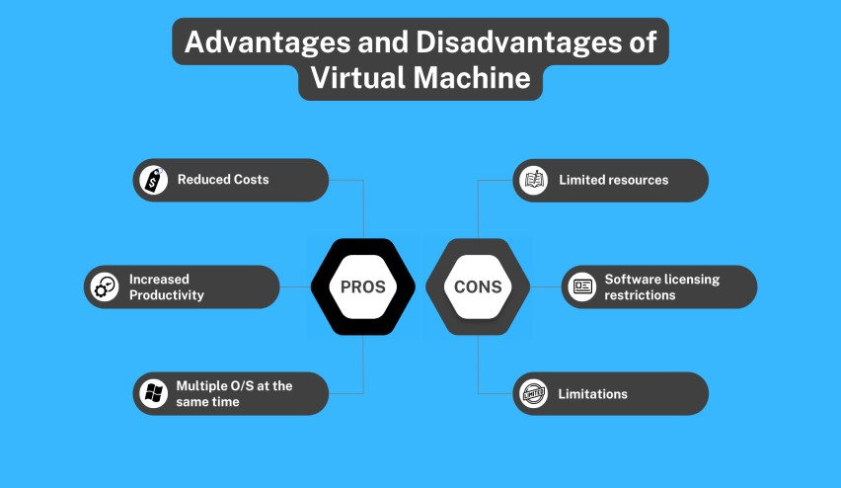

**VMs and containers**

The growth of VMs has led to further development of technologies such as containers, which take the concept another step and is gaining appeal among web application developers. In a container setting, a single application along with its dependencies, can be virtualized. With much less overhead than a VM, a container only includes binaries, libraries, and applications.

While some think the development of containers may kill the virtual machine there are enough capabilities and benefits of VMs that keep the technology moving forward. For example, VMs remain useful when running multiple applications together, or when running legacy applications on older operating systems.

In addition, some feel that containers are less secure than hypervisors because containers have only one OS that applications share, while VMs can isolate the application and the OS.

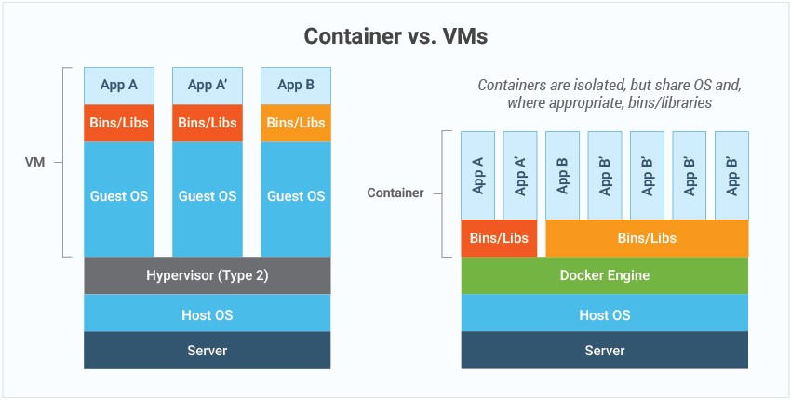

**CONCLUSION-**

Virtualization should never be seen as a simple solution to a specific problem; that is the main idea we have been trying to convey. It is a principle, a technology that is applicable in a very large range of different solutions. It is also a buzzword to get cash flowing nowadays, and is heralded by a lot of companies as "the next best thing in IT".

The purpose of this report is to make clear that I believe the current wave of virtualization will in fact make very big changes in datacenters as we know them, but also that it is not some new "holy grail of IT" and has always been a part of it in some way. It's important not to get carried away by all the recent hype surrounding the subject, but to understand each technology's purpose and how to make use of them in the most efficient way possible.

Virtualization should never be seen as a simple solution to a specific problem; that is the main idea we have been trying to convey. It is a principle, a technology that is applicable in a very large range of different solutions. It is also a buzzword to get cash flowing nowadays, and is heralded by a lot of companies as "the next best thing in IT".

The purpose of this article is to make clear that we believe the current wave of virtualization will in fact make very big changes in datacenters as we know them, but also that it is not some new "holy grail of IT" and has always been a part of it in some way. It's important not to get carried away by all the recent hype surrounding the subject, but to understand each technology's purpose and how to make use of them in the most efficient way possible.

As the virtualization technique of hardware and software is developing fast, it will be more common to use virtual machine in automation projects in the near future.